**Bachelor of Engineering (Honours) in Software and Electronic Engineering**

**GMIT Department of Electrical and Electronic Engineering**

**Year 1**

**Industrial Automation**

**Gabriel Farragher 2022**

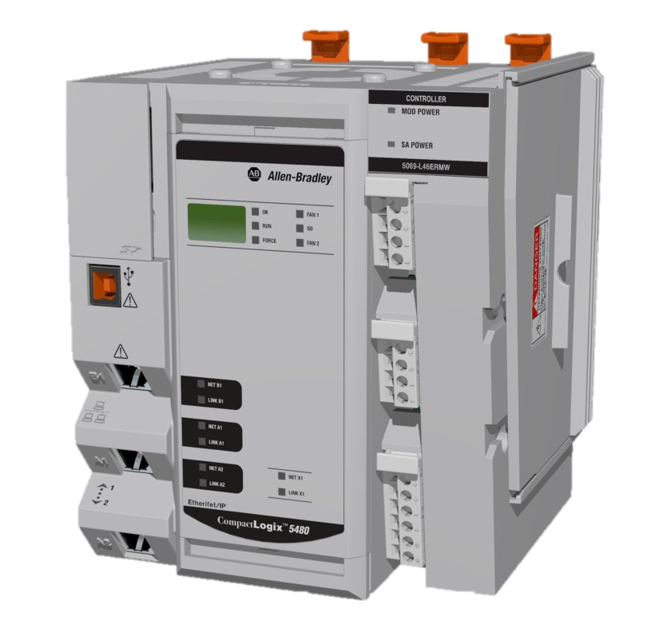

# Student Details:

* **Date: January – April 2022**
* **Module: Industrial Automation**
* **Student Name:**
* **Student Number:**
* **Lecturer: Gabriel Farragher**
* **Document: Lab Reports**

# Table of Contents:

1 Student Details: 2

2 Table of Contents: 3

3 Table of Figures: 3

4 GX Works 2- Exercise 3 - Timers 6

4.1 Delay Off Timer: 8

4.2 Flip Flop Timer: 9

4.3 Retentive Timer Lab Introduction: 10

4.3.1 Non-Retentive Timer: 10

4.3.2 Retentive Timer: 10

4.3.3 Retentive Timer FBD Exercise: 10

4.4 Pulse Timer TP Lab Introduction: 12

4.4.1 How the TP works: 12

5 GX Works 2– Exercise 4 – I/O: 15

# Table of Figures:

**No table of figures entries found.**

**Notes:**

|  |
| --- |
|  |
|  |
|  |
|  |
|  |
|  |
|  |
|  |
|  |
|  |
|  |
|  |
|  |
|  |
|  |
|  |
|  |
|  |
|  |
|  |

# GX Works 2- Exercise 3 - Timers

**Lab Overview:**

* **Develop skills with function block On Delay Timers TON.**
* **Develop skills with function block Off Delay Timers TOF.**
* **Develop skills with function block Retentive Timers RTO.**
* **Develop skills with function block Pulse Timers TP.**
* When Push Button S1 is pressed two lamps alternate On/Off (e.g. Flashing at opposite intervals).
* Develop the Ladder Logic for this operation.
* When S1 is Off both lamps are Off.
* Include Comments.

**PLC I/O Addresses:**

* **iS1 X1**

**oLamp_1 Y1**

* **oLamp_2 Y2**

**[Note: Save PLC software file as: GX W2 L2 Ex 1 GF]**

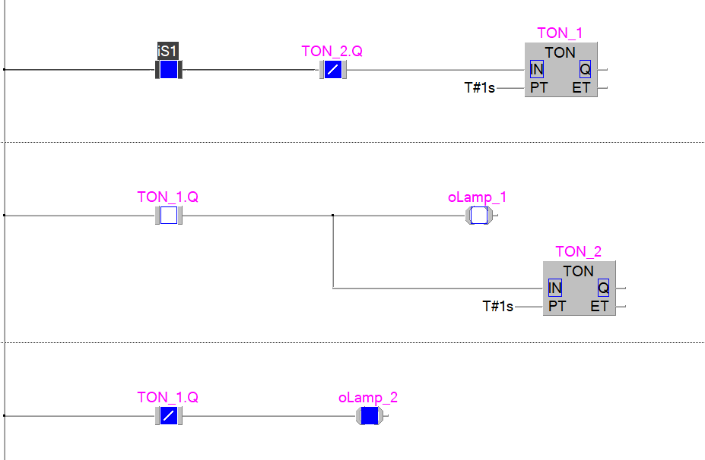

|  |  |  |
| --- | --- | --- |
| TON | Timer On-Delay | Counts time base intervals when the instruction  is true. |
| TOF | Timer Off-Delay | Counts time base intervals when the instruction  is false. |
| RTO | Retentive Timer | Counts time base intervals when the instruction  is true and retains the accumulated value when  the instruction goes false or when power cycle  occurs. |

## Delay Off Timer:

**Lab Overview:**

* **Delay Off Exercise.**
* **A Momentary Booster Switch Push Button S1 is used to send a run signal to an Extraction Fan.**
* **When S1 is pressed the Fan Starts to extract.**
* **It will be remaining extracting for a given period after the button is released.**
* **In this case set the delay Off for 20 seconds.**
* **Develop the Ladder Logic for this operation.**
* **Include Comments.**

**PLC I/O Addresses:**

* **iBooster_SW X1**
* **oExtraction_Fan Y1**

**[Note: Save PLC software file as: GX W2 L2 Ex 2 GF]**

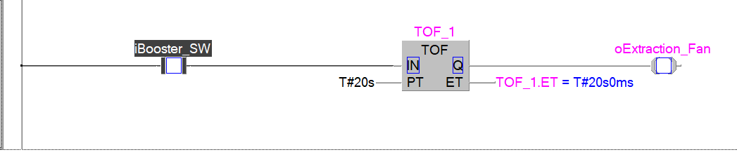

## Flip Flop Timer:

**Lab Overview:**

* **Flip Flop Timer Exercise.**
* **A Conveyor Belt needs to operate for 6 seconds and then remain off for 12 seconds.**
* **A momentary Start Push button runs the program.**
* **The cycle repeats until the Stop Push Button is pressed.**
* **Develop the Ladder Logic for this operation.**
* **Include Comments.**

**PLC I/O Addresses:**

* **iStart_PB X1**
* **iStop_PB X2**
* **oConveyor_Belt Y1**

**[Note: Save PLC software file as: GX W2 L2 Ex 3 GF]**

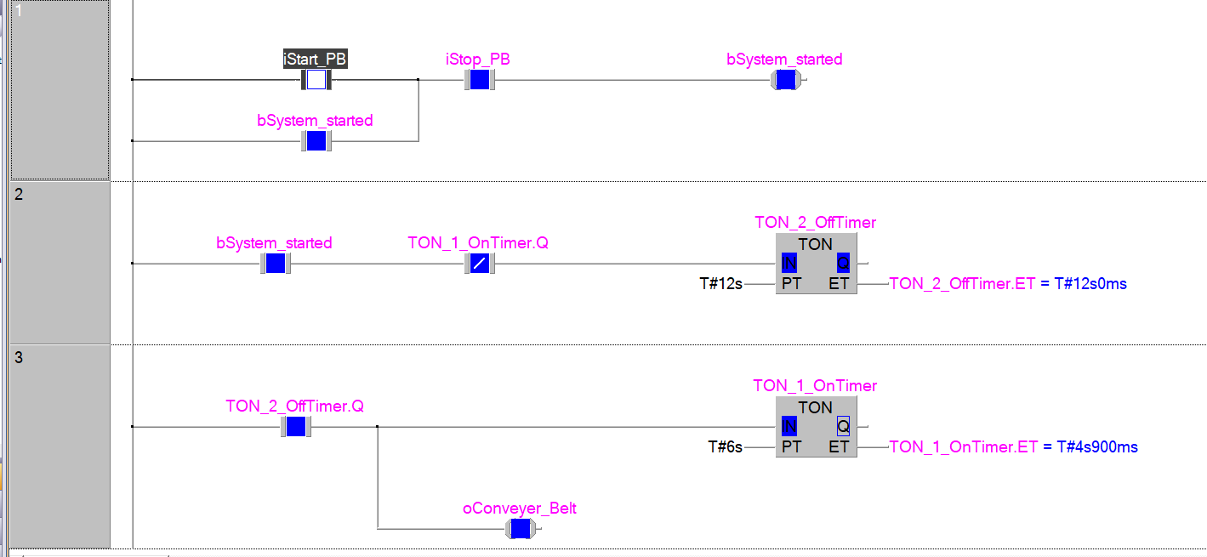

## Retentive Timer Lab Introduction:

### Non-Retentive Timer:

* This is the most used timer. It does not hold the timing accumulated if the PLC loses power or if the line of code goes low.

### Retentive Timer:

* This timer holds the value until the cycle is complete.
* Let say the timer is set to accumulate to 10 seconds. The code for this output becomes high and the timer starts accumulating. Next, the code goes low unexpectedly or the power to the PLC got switched off etc. The accumulation may have reached 4 seconds.
* If it were a normal timer this 4 second would be lost. That could mean a milk bottle was 40% filled when the power cut. Using a retentive timer when the power is restored, the system knows the bottle is 40% filled therefore only another 60% left or in our example 6 seconds.

### Retentive Timer FBD Exercise:

**A retentive timer is used to fill bottles of chemicals.**

* The process requires 25 seconds of filling.
* The retentive timer should stop accumulating if the System Start PB is Off.
* When the System Start PB is On, the Retentive Timer accumulates, and the Fill Valve is On (Open).
* When the 25 seconds is reached, the system repeats.

**PLC I/O Addresses:**

* **iStartSysPB X1**
* **oFillValve Y1**

**[Note: Save PLC software file as: GX W2 L2 Ex 4 GF]**

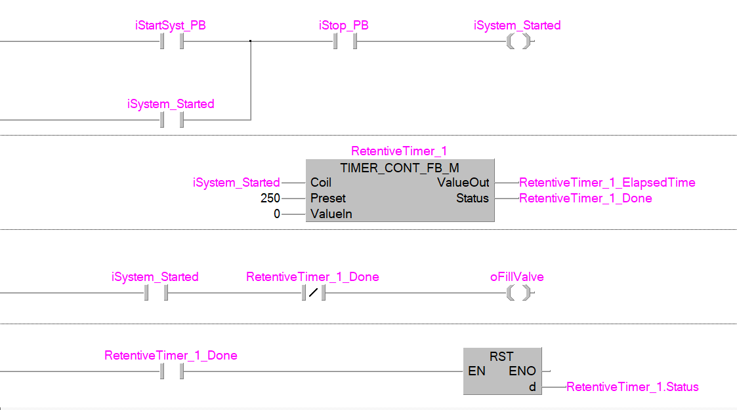

## Pulse Timer TP Lab Introduction:

### How the TP works:

**Use this timer to generate a pulse of specific duration. The TP Timer Out bit (Q) is ON when the timer is running and OFF at all other times.**

**When the input condition (IN) of a TP timer rises (positive RLO):**

* **The Timer Out bit (Q) turns ON**
* **The Timer begins to accumulate.**
* **Once the timer is running, it continues**regardless**of the state of the input condition. (It continues to accumulate to the Pre-set Time)**
* **When the Elapsed Time ET reaches the Pre-set Time PT Out bit (Q) is false. The Timer Out bit (Q) turns OFF.**

**Practical Use: A TP timer could be useful to prevent unnecessary starting/stopping of equipment. E.g., A Fan, A pump Etc. The TP ensures the given output runs for a predetermined time. This is useful in an automated environment.**

**PLC I/O Addresses:**

* **Design a TP program using GX W2 LD/FBD**

**[Note: Save PLC software file as: GX W2 L2 Ex 5 GF]**

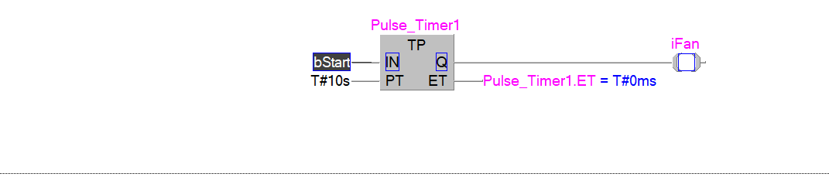

**Notes:**

|  |
| --- |
|  |
|  |
|  |
|  |
|  |
|  |
|  |
|  |
|  |
|  |
|  |
|  |
|  |
|  |
|  |
|  |
|  |
|  |
|  |
|  |